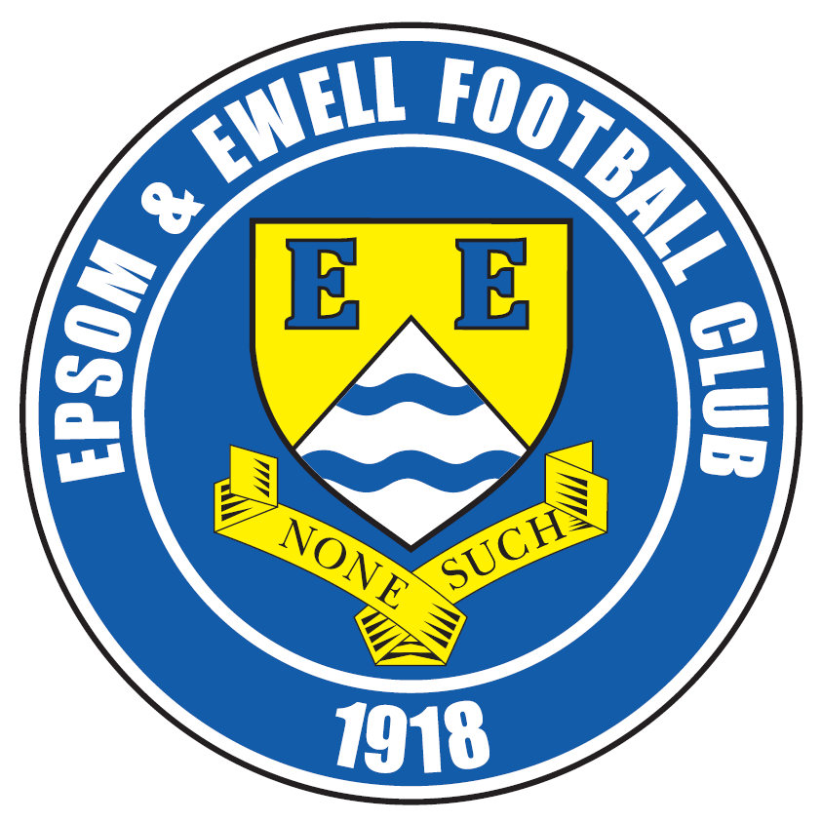 | Epsom & Ewell F.C.  23  v  Walton & Hersham F.C.  Saturday, 4th March 2017 – 3.00 p.m.
Good afternoon! We welcome the players, supporters and officials of Walton & Hersham Football Club, today’s officials and our own regular faces for this important League match.

Our opponents have adapted well to their new surroundings following relegation from the Isthmian League last season. Our results so far have been good as we secured a 1-1 draw there in October before returning from Stompond Lane in January with a 3-1 League Cup Quarter-Final win. However, they are still well placed for a top four finish if any of the teams above them slip up.

We are in a very similar situation, as we currently sit just a point behind today’s opponents who currently occupy fourth place and know that a home win today would be very useful. For those who are not aware, a top four finish would earn us an exemption to the First Round of the F.A. Vase, which may not appear much at first, but around half of the clubs in our division fail to make it through the two qualifying rounds each year and not playing those two matches also provides us with an opportunity to get a couple more league matches played, so it can be very helpful.

Recent results have left us with an outside chance of chasing Westfield down for the second place position that may yet even secure promotion if Hartley Wintney do not get their ground up to Step Four level, so it is important to keep going..

We were last here two weeks ago when we played well, especially in the second half to defeat Westfield 2-1. We then followed this up with a hard fought 1-0 win at Abbey Rangers just two days later, although on Saturday we could only draw 2-2 at Spelthorne Sports. We’ve played better, but I thought we did enough to win, even if we required a late equaliser to even get a point!

On Tuesday we are back here for the visit of Bedfont & Feltham after the match was originally frozen off on 21st January and we then have next Saturday off before visiting Bedfont & Feltham’s ground for a League match against Bedfont Sports the following Wednesday, then retuning here two weeks today for the big test against Champions elect Hartley Wintney.

There have been some bizarre occurrences in the world of football in recent weeks. We will all be aware by now of the “piegate” scandal that has engulfed Sutton United. More recently still we have seen the departure of Claudio Ranieri within 12 months of writing the most incredible football story of the last 25 years. It is at times like this I am thankful that I support a proper non-league club where football is the priority, instead of all the sideshows created by the media and the two clubs concerned, neither of which come out with any credit for their actions, in my opinion.

Enjoy the game!

Rich
You can follow us on Facebook: www.facebook.com/epsomandewellfc
Twitter: @EEFCOfficial Instagram at: www.instagram.com/epsomandewellfc
and on Youtube at: www.youtube.com/channel/UCtLrpS0x5OaYUACRT34_zng

Today’s Cover Photos

- Dan Dean celebrates his winning goal at Abbey Rangers on Monday 20th February

- Michael Eacott earning another clean sheet in that same match


Cherry Red Records Combined Counties League
Premier Division Table 2016/17
inc Tuesday 28th February | P | W | D | L | F | A | Pts | GD | H | A
Hartley Wintney | 35 | 29 | 4 | 2 | 118 | 34 | 91 | +84 | 18/3 | 1-3
Westfield | 32 | 20 | 7 | 5 | 75 | 37 | 67 | +38 | 2-1 | 1-2
Hanworth Villa | 35 | 20 | 7 | 8 | 61 | 38 | 67 | +23 | 2-2 | 0-1
Walton & Hersham | 34 | 17 | 12 | 5 | 60 | 35 | 63 | +25 | 4/3 | 1-1
Epsom & Ewell | 34 | 18 | 8 | 8 | 73 | 44 | 62 | +29 | X | X
Camberley Town | 32 | 16 | 5 | 11 | 66 | 45 | 53 | +21 | 0-0 | 1/4
Horley Town | 32 | 15 | 6 | 11 | 69 | 54 | 51 | +15 | 3-0 | 17/4
Abbey Rangers | 34 | 14 | 7 | 13 | 57 | 60 | 49 | -3 | 7-1 | 1-0
Knaphill | 32 | 14 | 4 | 14 | 60 | 62 | 46 | -2 | 4-0 | 8/4
Guildford City | 36 | 13 | 6 | 17 | 67 | 73 | 45 | -6 | 1-0 | 2-0
Windsor | 33 | 12 | 8 | 13 | 62 | 56 | 44 | +6 | 2-0 | 1-2
Bedfont Sports | 30 | 12 | 7 | 11 | 50 | 56 | 43 | -6 | 5-1 | 15/3
Spelthorne Sports | 33 | 12 | 6 | 15 | 60 | 61 | 42 | -1 | 3-2 | 2-2
Farnham Town | 34 | 12 | 5 | 17 | 54 | 67 | 41 | -13 | 25/3 | 2-1
North Greenford United | 29 | 12 | 4 | 13 | 58 | 54 | 40 | +4 | 22/4 | 1-2
Sutton Common Rovers | 30 | 12 | 4 | 14 | 46 | 49 | 40 | -3 | 2-1 | 1-1
Colliers Wood United | 31 | 10 | 9 | 12 | 51 | 56 | 39 | -5 | 14/4 | 0-5
AFC Hayes | 34 | 10 | 8 | 16 | 52 | 65 | 38 | -13 | 2-2 | 0-1
CB Hounslow United | 33 | 11 | 4 | 18 | 46 | 66 | 37 | -20 | 1-5 | 2-0
Chertsey Town | 32 | 9 | 6 | 17 | 41 | 75 | 33 | -34 | 2-1 | 3-0
Badshot Lea | 34 | 7 | 4 | 23 | 46 | 94 | 25 | -48 | 4-2 | 4-1
Raynes Park Vale | 33 | 5 | 8 | 20 | 37 | 71 | 23 | -34 | 1-1 | 1-1
Bedfont & Feltham | 32 | 5 | 5 | 22 | 40 | 97 | 20 | -57 | 7/3 | 9-2

Lucky Day? – 4th March
Played 12 - Won 5 Drawn 3 Lost 4 - For 26 Against 18 - PPG 1.50 - Average
Our Club record against today’s opponent
Played 51 - Won 25 Drawn 10 Lost 16 - For 104 Against 98 - PPG 1.67 - Above Average
Our Largest wins and losses against today’s opponent
2nd October 1926 - W 8-0 – Surrey Senior League (H)
8th December 1945 - L 1-9 - London Senior Cup Second Round (A)
Their Last Visit
27th January 2010 - Lost 4-5 a.e.t. - Surrey Senior Cup

EL Records Premier Challenge Cup
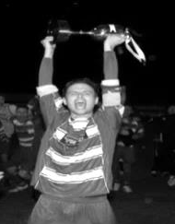
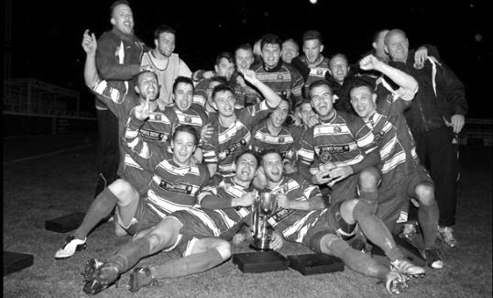
Quarter Finals
Windsor | 2-0 | Horley Town
Guildford City | 1-2 | Raynes Park Vale
Westfield | 4-1 | Camberley Town
Walton & Hersham | 1-3 | Epsom & Ewell
Semi Finals
Epsom & Ewell | 21/3 | Windsor
Raynes Park Vale | 21/3 | Westfield

Latest Results and Fixtures
Combined Counties League – Saturday 18th February
Abbey Rangers | 1-1 | Hanworth Villa
Camberley Town | 3-3 | Colliers Wood United
CB Hounslow United | 0-2 | Hartley Wintney
Epsom & Ewell | 2-1 | Westfield
Farnham Town | 4-1 | AFC Hayes
Guildford City | 2-0 | Bedfont Sports
North Greenford United | 2-0 | Horley Town
Raynes Park Vale | 0-1 | Badshot Lea
Spelthorne Sports | 0-1 | Sutton Common Rovers
Walton & Hersham | 2-0 | Bedfont & Feltham
Windsor | 1-2 | Chertsey Town
Combined Counties League – Monday 20th February
Abbey Rangers | 0-1 | Epsom & Ewell
Combined Counties League – Tuesday 21st February
Camberley Town | 2-6 | Westfield
Horley Town | 1-2 | Farnham Town
Combined Counties League Cup QF – Wednesday 22nd February
Guildford City | 1-2 | Raynes Park Vale
Latest Results and Fixtures
Combined Counties League – Saturday 25th February
AFC Hayes | 2-2 | Horley Town
Badshot Lea | 1-2 | Abbey Rangers
Bedfont & Feltham | 0-4 | Farnham Town
Colliers Wood United | 0-4 | Walton & Hersham
Hanworth Villa | 0-0 | Raynes Park Vale
North Greenford United | 0-1 | Hartley Wintney
Spelthorne Sports | 2-2 | Epsom & Ewell
Sutton Common Rovers | 4-0 | Knaphill
Westfield | 2-0 | Guildford City
Windsor | 2-2 | CB Hounslow United
Combined Counties League – Monday 27th February
Abbey Rangers | p-p | North Greenford United
Sutton Common Rovers | 1-2 | Hanworth Villa
Surrey Senior Cup QF – Tuesday 28th February
Chertsey Town | 0-3 | Dorking Wanderers
Combined Counties League – Tuesday 28th February
Knaphill | 2-2 | Bedfont Sports
Walton & Hersham | 2-0 | Raynes Park Vale
Westfield | p-p | Horley Town
Combined Counties League – Saturday 4th March
Camberley Town | V | Abbey Rangers
CB Hounslow United | V | Colliers Wood United
Chertsey Town | V | Badshot Lea
Epsom & Ewell | V | Walton & Hersham
Farnham Town | V | Hanworth Villa
Hartley Wintney | V | Windsor
Horley Town | V | Spelthorne Sports
Knaphill | V | Bedfont & Feltham
Raynes Park Vale | V | Bedfont Sports
Sutton Common Rovers | V | AFC Hayes
Westfield | V | North Greenford United
Combined Counties League – Tuesday 7th March
Camberley Town | V | Sutton Common Rovers
Chertsey Town | V | North Greenford United
Epsom & Ewell | V | Bedfont & Feltham
Horley Town | V | Knaphill
Westfield | V | Spelthorne Sports
Combined Counties League – Wednesday 8th March
Bedfont Sports | @ Bedfont & F FC | Farnham Town
Colliers Wood United | V | Raynes Park Vale
Latest Results and Fixtures
Combined Counties League – Saturday 11th March
Abbey Rangers | V | Raynes Park Vale
AFC Hayes | V | Chertsey Town
Badshot Lea | V | Bedfont & Feltham
Bedfont Sports | V | Horley Town
CB Hounslow United | V | Spelthorne Sports
Colliers Wood United | V | North Greenford United
Guildford City | V | Camberley Town
Hartley Wintney | V | Westfield
Knaphill | V | Hanworth Villa
Walton & Hersham | V | Farnham Town
Windsor | V | Sutton Common Rovers
Combined Counties League – Tuesday 14th March
AFC Hayes | V | Spelthorne Sports
North Greenford United | V | Abbey Rangers
Walton & Hersham | V | Colliers Wood United
Windsor | V | Bedfont & Feltham
Surrey Senior Cup Semi-Final – Wednesday 15th March
Guildford City | V | Woking
Combined Counties League – Wednesday 15th March
Bedfont Sports | V | Epsom & Ewell
Match to be played at Bedfont & Feltham FC
Combined Counties League – Saturday 18th March
Bedfont & Feltham | V | Colliers Wood United
Camberley Town | V | AFC Hayes
Chertsey Town | V | Raynes Park Vale
Epsom & Ewell | V | Hartley Wintney
Farnham Town | V | Knaphill
Hanworth Villa | V | Badshot Lea
Horley Town | V | CB Hounslow United
North Greenford United | V | Guildford City
Spelthorne Sports | V | Abbey Rangers
Sutton Common Rovers | V | Walton & Hersham
Westfield | V | Windsor
Combined Counties League – Monday 20th March
Sutton Common Rovers | V | Bedfont & Feltham
Combined Counties League Cup Semi-Finals – Tuesday 21st March
Epsom & Ewell | V | Windsor
Raynes Park Vale | V | Westfield

From behind the goal
Epsom & Ewell 2-1 Westfield
Combined Counties League - Premier Division - Saturday 18th February 2017

Five in a row for Salts

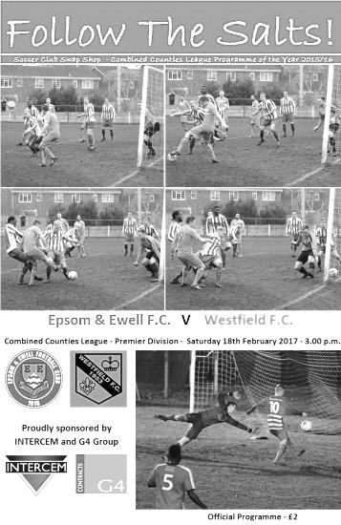
For the second match in a row both Daryl Cooper-Smith and Matt Ferdinando scored to earn us all three points in a League match, but if they were handing out prizes for achievement all eleven players would deserve one as we produced another great all round team performance to beat one of the best clubs in the League and extend our run to five straight wins in the process.

In what was the first ever home match to take place on this day in the club's entire history our Management and players were keen to gain a measure of revenge for their comprehensive 2-1 defeat at Woking Park in September. With former Salt James Cottee also added to their ranks along with in form striker Max Blackmore this was always going to be a challenge, but we were going into the match in good form of our own so were well up for it.

It was nice to see some more of our players were available again after we were badly short against CB Hounslow United on Tuesday and our defence looked more like it had done previously this season with James Taylor coming in alongside Captain Dan Dean and with Matt Tanton back on the left.

We started well, forcing three consecutive corners in the opening ten minutes but the visitors weathered the storm. However, we took the lead in the 12th minute when a weak defensive header fell straight to Cooper-Smith nearly thirty yards out and he smashed the ball over Gary Ross in the Westfield goal and just under the bar to register a candidate for the goal of the season award. It also happened to be his 30th goal of the season and his 50th for the club in just his 71st appearance, a tremendous achievement.

The opposition responded quickly and were almost on level terms within thirty seconds but Michael Eacott was out quickly to make a low save and big Mike had to make another one shortly afterwards, this time as a result of a poor clearance of his own! The remainder of the first half followed a similar pattern as Westfield spent much of the period attacking and with us playing on the counter. It was working fairly well, although Eacott had needed to make a couple of further saves as we reached the half hour mark.

An error in controlling the ball Dean forced him into conceding a free kick and inevitable yellow card and from the delivery a header was sent in on goal but the ball

was volleyed away to safety by Taylor. However, just when it looked like we would go in to the break holding the narrow lead a miscommunication between Matt Farrell and Jordan Gallagher resulted in the latter giving the ball straight to Cottee and he struck the ball into the net from 20 yards, giving Eacott no chance whatsoever.

Although we had done well to this point, we knew we would need to improve further if we were to take anything out of this match as the visitors had the momentum and had bossed the majority of the first forty five minutes. They continued to attack and missed the target from a near post corner before Karle Carder-Andrews broke through on the right but dragged his shot across the face of goal.

However, the pattern of the game was about to change. A good run by Adam Heagney set up Ferdinando who laid the ball back to Cooper-Smith who let fly with an extremely powerful shot from 25 yards. Although the shot was straight at Ross, he was unable to hold on to it and Farrell was unfortunate to incur a foul just as he was closing in on the loose ball. On 65 minutes we had a good opportunity as Ferdinando won a header which Reisse Griffin, resuming his regular position on the right wing, was able to run onto, but his attempt to lob Ross was not quite high enough to get over him.

We continued to attack though and in the 71st minute we scored what proved to be the winner. Ferdinando started and finished the move, setting up Griffin for a low right wing cross that was just behind Cooper-Smith but he did enough to make it difficult for the defender to clear the ball and Ferdinando pounced on it, driving it in to the bottom corner from ten yards out.

We managed to keep Westfield at arm's length for the remainder of the match. There was a scare when a Westfield attacker fell under a Tanton challenge just outside the box but after consultation with his Assistant, the Referee awarded the free kick the other way for a dive. It was indicative of the confident, unfussy and communicative display we were seeing from the man in black who surely will be promoted with further performances like this.

And although promotion is probably still beyond us, we knew that we needed a win to stand any chance whatsoever of catching Westfield for second place and even then that is only relevant if Champions elect Hartley Wintney fail to get their ground up to the required standard. Still, we closed the gap to three points and the possibility remains for now.

Also a possibility if the two Semi-Finals work out as they should on paper, would be a League Cup Final against Westfield. If that happens we will know that they are beatable now. It would make for a cracking final but we'll worry about that if we can negotiate the Semi-Final against Windsor. For now we have to recover quickly before a tricky trip to Abbey Rangers on Monday evening, hoping to extend our winning run still further.

Epsom and Ewell: Michael Eacott, Adam Heagney, Matt Tanton, James Taylor,
Dan Dean ©, Savvas 'Agi' Panayiotou, Jordan Gallagher, Matt Farrell,
Daryl Cooper-Smith, Matt Ferdinando, Reisse Griffin

Subs: Ali Dewar for Ferdinando (92)

From behind the goal
Abbey Rangers 0-1 Epsom & Ewell
Combined Counties League - Premier Division - Monday 20th February 2017

Hard earned win at the Moor keeps Epsom on track

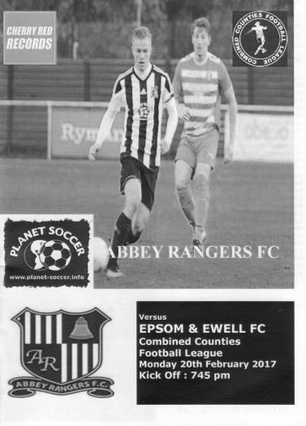
Dan Dean's first goal of the season early in the second half was sufficient to separate two hard working and fully committed teams on our first ever visit to Addlestone Moor. Make no mistake though, this was a very close match and some would not agree that we had done quite enough to win on the night. This is no criticism of our players. It was just that Abbey gave a fine display too and will probably consider themselves aggrieved that they didn't come away with a point.

With a quick two day turnaround following our win over Westfield, we only made one change with Jason Nwachukwu coming in for the injured Matt Ferdinando. On an extremely wide pitch, surely the largest in the League, it was strange to see neither side using the flanks quite as much as I thought they would, with much of the play being in the middle of the park, where it was extremely combative.

We had a couple of opportunities in the opening ten minutes though with Reisse Griffin prominent in the early exchanges. His whipped cross was just inches too far ahead of Matt Farrell who could only get the faintest of touches to the ball with his head, but in the 8th minute, Griffin sent a fine volley towards goal from an angle, although Liam Stone in the Abbey net was able to react well to turn the ball over the bar for a corner.

The visitors responded with a deep free kick to the far post, but it was headed clear while a minute after this Farrell was unable to direct another header on target from Jordan Gallagher's cross and the ball sailed over the bar.

We had our first moment of controversy in the 24th minute when Gallagher beat his man, James Shannon, who then promptly tugged his shirt to pull him back. You don't get many clearer yellow cards than this but for some reason, and despite obviously seeing the incident, the referee decided that no card was necessary.

Michael Eacott had to be down quickly to cut out a low right ring cross before another delivery from the same area was headed over our bar. There was an interesting battle going on between Patrik Ruzicka, who had scored a hat trick against us in our last meeting, against Matt Tanton and our man did well over there to keep him fairly quiet.

We were back on the attack soon after and Daryl Cooper-Smith drove the ball just wide of Stone's left hand post from outside the penalty area. Within a minute Griffin had done similar, this time with the ball just missing the right hand post. Then a few minutes after that Farrell appeared to be taken out from behind. This time a card was issued but incredibly it was in Farrell's direction apparently for something he said. It's good to see that the referee had his priorities right!

The game restarted for the second period with our boys just looking the better of the two teams. James Taylor won us a corner although this was cleared, and we had another worrying situation

when there was a foul in the middle of the field but the Abbey player got through anyway and his low shot was saved by Eacott. Despite having a free unimpeded shot at goal, the referee then pulled the game back for an Abbey free kick. I was starting to get concerned that we were going to lose the match because of something controversial that was beyond our control, but our players stepped up a gear and nearly scored in the 52nd minute when a clever pass from Cooper-Smith set Nwachukwu through on goal, but from ten yards out Stone got a foot to his low shot and the ball was diverted agonisingly wide of his right hand post for another corner.

In the 54th minute we had another moment of controversy when Farrell was bundled over by Shannon out on the left flank which finally earned him a yellow card. However, had he received his earlier one they would have been down to ten men with this offence. In fact, for the first time in four meetings between the teams we wouldn't see a red card tonight. Instead we exacted maximum revenge a minute later when Gallagher delivered a low ball in to Cooper-Smith at the near post, but he completely fooled those around him by dummying the ball through his legs and Dean was first to the ball to force it in at the far post, just ahead of a defender.

The home side responded well and Eacott was forced into a low save within a minute. Their central midfielder Paul Hodges was having a great game and he was at the heart of many Abbey attacks. They nearly got through on the hour mark but Dean made a perfectly timed challenge to clear the danger. In response Gallagher had a good run on the left and twisted and turned his opponents but got too close to their near post and the danger was cleared, breaking at pace and requiring Eacott to make another low save with his feet.

A quick free kick then caught us out with quarter of an hour remaining but we recovered to concede a corner. However, we were being pushed back and Gallagher conceded a yellow card for a foul which stopped a break by Shannon on their right wing, and was probably the right decision, although Abbey's Tom Bentley could and should have been in trouble for running over to Gallagher and pushing him away right in front of the referee. They then had a shot from the edge of the area that was completely sliced out to Ruzicka on the right who was able to put in a good cross but it was headed over. This was probably their best chance of the evening, looking back.

We had a scare when Eacott dropped a routine cross but fortunately was able to react to gather the ball before his opponent could get there and with just three minutes remaining Hodges beat a couple of men with a mazy run but drilled his shot just wide of the joint of our goal. It was getting tense out there, although Abbey were taking risks by this stage and Griffin intercepted the ball in a dangerous area, but with Gallagher waiting in acres of space to his side he went for goal from just inside the area and admittedly, didn't miss the far post by very much. Despite only two substitutions in the half and no injuries we had to wait for over four minutes before the final whistle went, which confirmed our sixth win in a row.

Every single one of these wins has required us to dig deep, but the rewards of our work can be seen by looking at the League table. We are now level on points with Westfield and just two behind Hanworth Villa, and in the Semi-Final of the League Cup. What looked like an average season is shaping up to be quite a good one, and whilst there will always be a degree of disappointment about Abbey ending our Vase run, we have won the other three meetings against a team that will surely be a challenger in the seasons to come. Maybe Deano's goal will turn out to be a hugely significant one. Time will tell.

Epsom and Ewell: Michael Eacott, Adam Heagney, Matt Tanton, James Taylor,
Dan Dean ©, Savvas 'Agi' Panayiotou, Jordan Gallagher, Matt Farrell,
Daryl Cooper-Smith, Jason Nwachukwu, Reisse Griffin

Subs: Rob Hendry for Nwachukwu (94)

Walton & Hersham F.C. – History
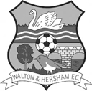
Walton-on-Thames F.C. was formed in 1895, and in 1945, following World War II, amalgamated with Hersham F.C. to form Walton & Hersham F.C., the present club.

The united club immediately joined the newly formed Corinthian League and followed a poor first season with a hat-trick of Championships and a runners-up position.

They also won the Surrey Senior Cup for the first time in 1947-48, beating Isthmian League neighbours Kingstonian 2-1 at Crystal Palace.

Election to the Athenian League soon followed and in their first season, 1950-51, Swans finished runners-up and again won the Surrey Senior Cup at Palace, defeating the much vaunted Dulwich Hamlet 2-1.

Great days, big crowds

These were halcyon days for the Stompond Lane side and the Amateur Cup Semi-Final was reached in successive seasons, 1951-52 and 1952-53, only for Swans to go out to Walthamstow Avenue and Harwich & Parkeston respectively.

During this period the club enjoyed a tremendous following, and a record crowd of 10,000 were at the Lane in 1952 when the famous Crook Town were the visitors for an Amateur Cup tie. Stars of this era included Swans’ most famous player, England and Great Britain Olympic defender C.R. ‘Jack’ Neale, and the prolific Reg Sentance, still the club’s all-time top scorer.

Some lean years followed, although the F.A. Cup First Round was reached for the first time in 1957-58, Southampton winning 6-1 before 6,000 people at Stompond Lane. Don Stoker’s popular sides of the early 1960’s brought cup fever back to the Lane and there were fine runs again in the Amateur Cup.

Two late goals by the prolific and popular (former Epsom player) Brian Jenkins beat the star-studded Wimbledon side in the Surrey Senior Cup Final of 1960-61, and the trophy was retained against Sutton United the following season.

After several years of mid-table respectability the appointment of Allen Batsford as manager in 1967 heralded the beginning of the most successful period in the club’s history. At the end of his first season, a superb victory over a powerful Wimbledon side in the two legged Final secured the Premier Midweek Floodlit League title, the first of three, followed a year later by the winning of the Athenian League championship for the first time.

The FA Cup First Round Proper was again reached in the following two seasons, only for Swans to lose to Barnet 1-0 in 1969-70 and Telford United 5-2 in 1970-71, both games being played at the Lane. The runners-up spot in the League was achieved in both those campaigns and the Surrey Senior Cup came back to Stompond Lane in 1970-71, Woking being defeated 3-0 in the Final.

Election to the Isthmian ranks followed, with third place attained in the first season, 1971-72.

Wembley at last

Then followed the most memorable season in the club’s history, 1972-73. The F.A. Cup First Round barrier was overcome for the first time with Exeter City being defeated 2-1 amid tremendous excitement at the Lane, only for visitors Margate to win by the only goal in the

Second Round.

Kingstonian were beaten 2-0 in the Surrey Senior Cup Final and the runners-up spot achieved in the League. Then on the 14th of April 1973 the ultimate prize was gained at Wembley when 41,000 people saw a last-minute Roger Connell goal against Slough Town bring the FA Amateur Cup to Stompond Lane, the trophy being won without a goal being conceded, a record never to be equalled. Additionally, Dave Bassett, Willie Smith and Connell also had the honour of playing for the England Amateur side.

The following season Brian Clough brought his Brighton & Hove Albion side to Stompond Lane in the F.A. Cup First Round, and following a goalless draw, Swans pulled off a sensational result in the replay at The Goldstone Ground, a Clive Foskett hat-trick included in a 4-0 win. Sadly, when Batsford left for Wimbledon the following season the fine team broke up, the crowds drifted away, and relegation soon followed in 1975.

The FA Cup First Round was surprisingly reached in 1975-76, and a young side put on a battling performance at Selhurst Park against Malcolm Allison’s Crystal Palace, only going down 1-0 to a late goal.

Barren years followed, with the club several times being close to extinction. In the mid 1980’s the club was proud to have Sir Stanley Matthews as President, but sides flattered to deceive and only a draw in the final game of the 1986-87 season prevented relegation to Division Two.

Promotion

After 20 years out of the top-flight, a young side under Neil Price at last gained promotion in 1993-94, and the following season the First Round Proper of the FA Cup was again reached, Swansea City winning 2-0 at the Lane. However Swans’ Centenary celebrations were spoilt by relegation after only two seasons back in the Premier.

Under the management of Laurie Craker the team ensured the stay in Division One was as brief as possible, promotion being gained on the last day of the campaign. After a creditable first season back in the Premier Division it again proved to be a struggle to remain there, and at the end of the 1999-2000 season Swans finished in bottom spot and relegation again became a reality.

Swans had to wait until the 2004-05 season before more success came to Stompond Lane after long-serving player Alan Dowson took over as manager in October. After defeat in his first match in charge, Dowson led the team to a record breaking 13 match winning sequence, fine runs in the F.A. Trophy and League Cup, and promotion as runners-up in the Ryman League Division One.

The Surrey Senior Cup Final was reached for the first time in 31 years, the Swans only losing a thrilling game against AFC Wimbledon 2-1 after extra-time before close to 4,000 people at Woking.

After a creditable first season back in the Premier Division a poor start to 2006-07 led to Dowson’s early resignation and eventual relegation yet again.

Since then Swans remained in Division One, facing relegation fights on several occasions, until 2015-16, when a third from bottom finish finally saw them go down.

After a 45 year unbroken stay in the Isthmian League Swans now will now play the 2016-17 season in the Combined Counties League.

Club Records - 4th March
Date | Day | Competition |  | Opponents |  | Scorers
04/03/33 | Sat | London League | A | Bostall Heath | 3-3 | L.Marlow, J.Gillespie, T.Winship
04/03/39 | Sat | London League | A | Bostall Heath | 4-1 | J.Jones (2, 1 pen), B.Solly, G.Collins
04/03/50 | Sat | Corinthian League | H | Maidenhead United | 1-1 | R.Leverington
04/03/72 | Sat | Athenian League 2 | H | Staines Town | 1-2 | R.Sears
04/03/80 | Tue | Southern Combination Cup 2 | H | Wandsworth | 3-2 | T.Tuite (2), M.Harriott
04/03/89 | Sat | Isthmian League 2s | A | Yeading | 2-3 | P.Andrews, B.Perkins
04/03/95 | Sat | Isthmian League 3 | H | Tring Town | 1-1 | S.Miller
04/03/00 | Sat | Isthmian League 3 | H | Ware | 3-0 | B.Forey (2), J.Hall
04/03/03 | Tue | Isthmian League 1s | A | Tooting & Mitcham United | 4-3 | K.Webb (2), J.Rogers, R.Ingham
04/03/06 | Sat | Isthmian League 2 | H | Egham Town | 0-1
04/03/08 | Tue | Combined Counties  Premier Division | H | Chertsey Town | 0-1
04/03/14 | Tue | Southern Combination Cup QF | H | Old Hamptonians | 4-0 | J.Cottee, A.Dewar (2), K.Douglin
Historical Decades
Date | Day | Competition |  | Opponents |  | Scorers
90 years ago – Epsom Town F.C.
05/03/27 | Sat | Surrey Senior League | H | Weybridge | 10-0 | R.Marlow (3), F.Behn (3), F.Watts, J.Parr, E.Olley, G.Mackesy (pen)
80 years ago – Epsom F.C.
06/03/37 | Sat | London League | H | Streatham Town | 4-2 | H.Pullen (2, 1 pen), J.Jones, T.Dunne
70 years ago – Epsom F.C.
15/03/47 | Sat | London League | H | Leavesden | 1-4 | F.Taylor
60 years ago – Epsom F.C.
02/03/57 | Sat | Corinthian League | H | Uxbridge | 2-0 | B.Jenkins (2, 1 pen)
50 years ago – Epsom & Ewell F.C.
11/03/67 | Sat | Athenian League 2 | A | Aylesbury United | 3-1 | T.Stafford (2), C.Spriggs
40 years ago – Epsom & Ewell F.C.
05/03/77 | Sat | Athenian League 1 | H | Haringey Borough | 1-0 | T.Tuite
30 years ago – Epsom & Ewell F.C.
07/03/87 | Sat | Isthmian League 1 | H | Leytonstone/Ilford | 0-2
20 years ago – Epsom & Ewell F.C.
01/03/97 | Sat | Isthmian League 3 | H | Clapton | 1-2 | o.g.
10 years ago – Epsom & Ewell F.C.
07/03/07 | Wed | Combined Counties Premier | A | Guildford City | 0-4

History Corner - 4th March
90 years ago this week Reg Marlow was back to his scoring best again but he wasn’t the only one! It was just as well they didn’t give out match balls for hat tricks back then, as Freddie Behn also joined Marlow with three goals this day. The opposition were a midtable team and there were far worse clubs out there that season, but our 10-0 win at West Street came on the back of our 8-0 League win over there in the January of 1927. The other goals came from Fred Watts, Jack Parr, Ernest Olley and a George Mackesy penalty and we would be celebrating a Surrey Senior League and Cup double by the end of the season.

84 years ago today & 78 years ago today we made a couple of visits to Bostall Heath’s Wickham Street ground. For those of you who have not heard of them, which is probably quite a few of you, they were London League opponents from 1927/28 until the Second World War and they played in Welling, not a huge distance away from where Welling United now compete at Park View Road, although there is absolutely no connection between the teams.

The Heathens were not regular league title challengers with a high point of third place and in every one of the twelve seasons that we competed, we would finish higher than them. We drew there on this day in 1933, requiring a second half equaliser after we had trailed 3-2 at the break, while our 4-1 win in 1939 was far more comfortable, effectively winning the match in the first half when we turned around 3-0 up.

By this time the club knew that this season would be their last in the London League as they were losing their ground for housing and they never started the 1939/40 season. I am not aware of when the ground was built on, as any development must surely have been delayed by the onset of World War Two, but the club never rejoined the London League when the war ended, along with other famous non-league clubs like Nunhead, West Norwood and the London Caledonians.

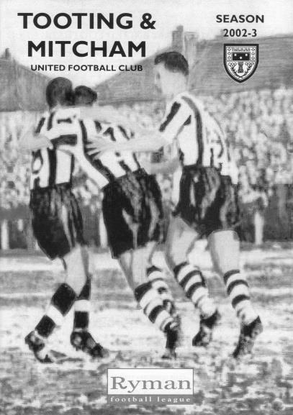
28 years ago today we visited The Warren, home of Yeading F.C. and it was goalless at half time, although the hosts had missed a penalty in the first period. We appeared to take full advantage as goals from Paul Andrews and Brian Perkins had us 2-0 up with just 18 minutes remaining, yet somehow we contrived to lose the match 3-2! Two further penalties were given against us which didn’t help. To my knowledge I can think of only two other matches where three penalties were awarded against us, one at Chertsey in a 2-2 draw and the other at home to Crowborough Athletic in a 7-1 F.A. Cup defeat at Merland Rise in 2007.

14 years ago today we made our first ever visit to Imperial Fields, the new home of Tooting & Mitcham, for a League match (see programme pictured). Actually that’s strictly untrue as we all turned up there on 7th January, only to suffer a late postponement, but when the match finally took place it was a cracker. We trailed to a long range strike before equalising when Kevin Webb drove a shot past former Epsom keeper and future Assistant Manager Tony Webb. We went behind again but recovered when Webb forced in Jamie Buckley’s cross and then Joel Rogers scored right on half time after Richard Ingham’s shot had been saved. Incredibly we then conceded a third goal from distance and four minutes from time had Kevin Webb sent off for retaliation, but as the home team pressed for a winner we got it on the counter attack when Simon Huckle’s shot was blocked and Ingham was there to tuck away the loose ball in injury time to win it 4-3!

Cherry Red Records Combined Counties League
Premier Division FORM Table – Last 6 Matches
Here is the current state of play based on everyone’s last six League matches. If we keep winning, the table stays in the programme!

inc Tuesday 28th February | P | W | D | L | F | A | Pts | GD
Hartley Wintney | 6 | 5 | 1 | 0 | 23 | 6 | 16 | +17
Epsom & Ewell | 6 | 5 | 1 | 0 | 14 | 5 | 16 | +9
Hanworth Villa | 6 | 4 | 2 | 0 | 11 | 5 | 14 | +6
Westfield | 6 | 3 | 1 | 1 | 13 | 6 | 10 | +7
Walton & Hersham | 6 | 3 | 1 | 1 | 12 | 6 | 10 | +6
Sutton Common Rovers | 6 | 4 | 0 | 2 | 12 | 5 | 12 | +7
Abbey Rangers | 6 | 3 | 2 | 1 | 10 | 8 | 11 | +2
Spelthorne Sports | 6 | 3 | 1 | 2 | 15 | 9 | 10 | +6
Farnham Town | 6 | 3 | 1 | 2 | 14 | 10 | 10 | +4
Camberley Town | 6 | 3 | 1 | 2 | 12 | 14 | 10 | -2
North Greenford United | 6 | 3 | 0 | 3 | 10 | 8 | 9 | +2
Chertsey Town | 6 | 3 | 0 | 3 | 7 | 12 | 9 | -5
Windsor | 6 | 2 | 2 | 2 | 13 | 7 | 8 | +6
Badshot Lea | 6 | 2 | 1 | 3 | 12 | 16 | 7 | -4
Guildford City | 6 | 2 | 0 | 4 | 6 | 9 | 6 | -3
Bedfont Sports | 6 | 1 | 1 | 3 | 5 | 9 | 4 | -4
AFC Hayes | 6 | 1 | 2 | 3 | 6 | 11 | 5 | -5
Colliers Wood United | 6 | 1 | 2 | 3 | 9 | 14 | 5 | -5
CB Hounslow United | 6 | 1 | 1 | 4 | 4 | 10 | 4 | -6
Knaphill | 6 | 1 | 0 | 4 | 5 | 11 | 3 | -6
Horley Town | 6 | 0 | 1 | 4 | 5 | 13 | 1 | -8
Raynes Park Vale | 6 | 1 | 1 | 3 | 4 | 10 | 4 | -6
Bedfont & Feltham | 6 | 1 | 0 | 5 | 9 | 22 | 3 | -13

How fast is Daryl Cooper-Smith?
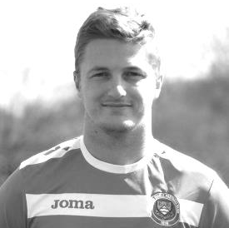
Congratulations go to Daryl Cooper-Smith who reached the 50 goal mark for our club with a beauty from nearly thirty yards to set us on our way to a win against Westfield.

Dazzer has been scoring at quite a rate for us, as this goal came in just his 72nd match, and as he becomes just the 26th player in club history to reach this mark, I thought it was worth a delve into the record books to see how quickly the other top strikers reached that particular milestone.

Now there are two ways of marking this, in days since debut, or in terms of matches played which is probably fairer, bearing in mind our man’s rather large suspension in 2015/16. I have sorted them that way in the analysis below and this tells me that he is the tenth fastest player to reach 50 goals in club history. Most impressive!

Name | Dates at Club | Pld | Sub | Tot | Goals | Debut | Date of  50th goal | Match  No | How Long
Billy Williams | 31/32-32/33 | 48 | 0 | 48 | 73 | 26/09/1931 | 17/09/1932 | 32 | 357
Johnny Bangs | 56/57-59/60 | 77 | 0 | 77 | 86 | 15/09/1956 | 22/04/1957 | 34 | 219
Leslie Marlow | 32/33-33/34 | 61 | 0 | 61 | 73 | 10/09/1932 | 06/01/1934 | 39 | 483
Bill Goddard | 51/52-54/55 | 73 | 0 | 73 | 97 | 06/10/1951 | 27/09/1952 | 40 | 357
Jackie Pullen | 34/35-38/39 | 106 | 0 | 106 | 104 | 15/12/1934 | 07/12/1935 | 41 | 357
Gordon Brogdale | 36/37-50/51 | 69 | 0 | 69 | 78 | 23/01/1937 | 12/10/1946 | 42 | 3549
Reg Marlow | 24/25-35/36 | 319 | 0 | 319 | 254 | 14/09/1924 | 05/04/1926 | 55 | 568
Tommy Tuite | 73/74-86/87 | 568 | 14 | 582 | 391 | 01/09/1973 | 19/10/1974 | 58 | 413
Freddie Behn | 26/27-31/32 | 136 | 0 | 136 | 89 | 13/11/1926 | 17/11/1928 | 66 | 735
Daryl Cooper-Smith | 14/15 - pres | 60 | 13 | 73 | 51 | 03/01/2015 | 18/02/2017 | 72 | 777
Andy Boxall | 90/91-98/99 | 172 | 15 | 187 | 97 | 20/10/1990 | 19/10/1996 | 84 | 2191
Dave Hermitage | 55/56-58/59 | 125 | 0 | 125 | 71 | 20/08/1955 | 19/10/1957 | 88 | 791
Jack Parr | pre24-35/36 | 188 | 0 | 188 | 101 | 30/08/1924 | 17/09/1927 | 91 | 1113
Steve Hill | 81/82-90/91 | 213 | 2 | 215 | 128 | 15/08/1981 | 02/04/1983 | 92 | 595
Brian Perkins | 87/88-89/90 | 111 | 6 | 118 | 55 | 22/08/1987 | 19/09/1989 | 97 | 759
Robbie Burns | 07/08-14/15 | 205 | 16 | 221 | 121 | 14/08/2007 | 18/04/2009 | 101 | 613
Jimmy Jones | 32/33-45/46 | 255 | 0 | 255 | 147 | 11/03/1933 | 12/10/1935 | 104 | 945
Tommy Dunne | 31/32-36/37 | 166 | 0 | 166 | 83 | 29/08/1931 | 29/09/1934 | 105 | 1127
Tommy Rochester | 35/36-51/52 | 135 | 0 | 135 | 54 | 11/04/1936 | 20/04/1948 | 105 | 4392
Kyle Hough | 07/08-15/16 | 333 | 19 | 352 | 201 | 14/08/2007 | 27/10/2009 | 110 | 805
Johnny Eales | 64/65-76/77 | 196 | 3 | 199 | 61 | 14/11/1964 | 11/10/1975 | 127 | 3983
Mark Jarman | 09/10-14/15 | 136 | 51 | 187 | 76 | 08/08/2009 | 13/04/2013 | 132 | 1344
Kevin Webb | 94/95-02/03 | 177 | 34 | 211 | 60 | 08/10/1994 | 27/04/2002 | 163 | 2758
Dale Marvell | 99/00-15/16 | 269 | 49 | 318 | 86 | 15/01/2000 | 17/01/2009 | 180 | 3290
Wilfred Challis | 24/25-34/35 | 202 | 0 | 202 | 57 | 20/12/1924 | 17/01/1931 | 187 | 2219
Andy Nimmo | 92/93-02/03 | 249 | 44 | 293 | 52 | 22/08/1992 | 28/04/2001 | 269 | 3171

Surrey Senior Cup
Third Round
Whyteleafe | 2-0 | Egham Town
Badshot Lea | 0-2 | Raynes Park Vale
Epsom & Ewell | 1-2 | Guildford City
Dorking Wanderers | 1-1 8p7 | Sutton Common Rovers
Chertsey Town | 1-0 | Kingstonian
Woking | 2-0 | Leatherhead
Merstham | 5-1 | Walton & Hersham
Tooting & Mitcham United | 0-1 | Knaphill
Quarter Final
Guildford City | 2-1 | Raynes Park Vale
Chertsey Town | 0-3 | Dorking Wanderers
Merstham | 2-1 | Whyteleafe
Woking | 3-1 | Knaphill
Semi Final
Guildford City | 15/3 | Woking
Dorking Wanderers | V | Merstham

F.A. Vase
Fifth Round – 28th / 29th January
Cleethorpes Town | 3-2 | Atherton Collieries
Southall | 4-2 | Exmouth Town
Bromsgrove Sporting | 2-1 | Bristol Manor Farm
Crowborough Athletic | 3-6 | Coleshill Town
Hinckley AFC | 3-4+ | Buckland Athletic
Newport Pagnell Town | 3-2+ | Sunderland RCA
Ely City | 0-3 | Sporting Khalsa
Team Solent | 2-5 | South Shields
Quarter - Final – 18th February
South Shields | 6-1 | Newport Pagnell Town
Southall | 2-5 | Cleethorpes Town
Bromsgrove Sporting | 2-0 | Buckland Athletic
Coleshill Town | 2-0 | Sporting Khalsa
Semi - Finals - two legs – 11th & 18th March
Coleshill Town | V | South Shields
South Shields | V | Coleshill Town
Bromsgrove Sporting | V | Cleethorpes Town
Cleethorpes Town | V | Bromsgrove Sporting

CCL Premier Division Club Directory
ABBEY RANGERS Telephone: 01932-422962 - Ground: Addlestone Moor, Addlestone, Surrey KT15 2QH - Colours: Black & White Stripes/Black/Black

A.F.C. HAYES Telephone: 0208-845-0110 - Ground: Farm Park, Kingshill Avenue, Hayes, Middx. UB4 8DD - Colours: Blue and White Stripes/Blue/Blue

BADSHOT LEA Telephone: 01252-320385 - Ground: Ash United FC, Shawfield Stadium, Youngs Drive, Shawfields Road, Ash, Hampshire. GU12 6RE - Colours: Claret/White/Claret

BEDFONT & FELTHAM Telephone: 0208 890 7264 - Ground: The Orchard, Hatton Road, Bedfont, Middx TW14 9QT - Colours: Yellow & Blue/Blue/Blue

BEDFONT SPORTS Telephone: 0208-831-9067 - Ground: Bedfont Sports Club, Hatton Road, Bedfont, Middx TW14 8JA - Colours: Red & Black Hoops/Black/Red & Black Hoops

CAMBERLEY TOWN Telephone: 01276-65392 - Ground: Krooner Park, Wilton Road, Camberley, Surrey. GU15 2QW - Colours: Red & White Stripes/Blue/Red

CB HOUNSLOW UNITED Telephone: 0208 890 7264 - Ground: The Orchard, Hatton Road, Bedfont, Middx TW14 9QT - Colours: Green/Black/Green

CHERTSEY TOWN Telephone: 01932-561774 - Ground: Alwyns Lane, Chertsey, Surrey. KT16 9DW - Colours: Royal Blue & White Stripes/Royal Blue/Royal Blue

COLLIERS WOOD UNITED Telephone: 0208-942 8062 - Ground: Wibbandune Sports Ground, Robin Hood Way, Wimbledon. SW20 0AA - Colours: Blue & Black Stripes/Black/Black
EPSOM & EWELL Telephone: 01737-553250 - Ground: Chipstead FC, High Road, Chipstead, Surrey. CR5 3SF - Colours: Royal Blue & White Hoops/Royal Blue/Royal Blue

FARNHAM TOWN Telephone: 01252-715305 Ground: Memorial Ground, Babbs Mead, West Street, Farnham, Surrey. GU9 7DY Colours: - Claret & Sky Blue /White/ Claret & Sky Blue

GUILDFORD CITY Telephone: 01483-443322 - Ground: The Spectrum, Parkway, Guildford, Surrey. GU1 1UP - Colours: Red & White Stripes/Black/Black

HANWORTH VILLA Telephone: 0208-831-9391 - Ground: Rectory Meadows, Park Road, off Hounslow Road, Hanworth, Middlesex. TW13 6PN - Colours: Red & White Stripes/Black/Black

HARTLEY WINTNEY Telephone: 01252-843586 - Ground: Memorial Playing Fields, Green Lane, Hartley Wintney, Hants RG27 8DL - Colours: Orange & Black/ Orange /Orange

HORLEY TOWN Telephone: 01293-822000 - Ground: The New Defence, Anderson Way, Court Lodge Road, Horley, Surrey. RH6 8SP - Colours: Claret & Sky Blue/Claret/Claret

KNAPHILL Telephone: 01483-475150 - Ground: Brookwood Country Park, Redding Way, Lower Guildford Road, Knaphill, Surrey. GU21 2AY - Colours: Red/Black/Red

NORTH GREENFORD UNITED Telephone: 0208 422 8923 - Ground: Berkeley Fields, Berkeley Avenue, Greenford, Middx UB6 0NX - Colours: Royal Blue & White/Royal Blue/Royal Blue

SUTTON COMMON ROVERS Telephone: 01932-866386 - Ground: Sutton United FC, Gander Green Lane, Sutton, Surrey SM1 2EY - Colours: Yellow/Black/Black

RAYNES PARK VALE Telephone: 020-8540-8843 - Ground: Prince Georges Playing Field, Grand Drive, Raynes Park, London. SW20 9NB - Colours: Blue/Blue/Red

SPELTHORNE SPORTS Telephone: 01932-961055 - Ground: Spelthorne Sports Club, Staines Road, Ashford Common, Ashford, Middx. TW15 1RY - Colours: Light & Dark Blue/Dark Blue/Light Blue

WALTON & HERSHAM Telephone: 01932 245263 - Ground: Stompond Lane, Walton on Thames, Surrey KT12 1HF - Colours: Red/Red/Red

WESTFIELD Telephone: 01483-771106 - Ground: Woking Park, Kingfield Road, Woking, Surrey. GU22 9BA - Colours: Yellow/Black/Black

WINDSOR Telephone: 01753-860656 - Ground: Stag Meadow, St Leonards Road, Windsor, Berks SL4 3DR - Colours: Red/Red/Red

Centre page for results

Centre page for results


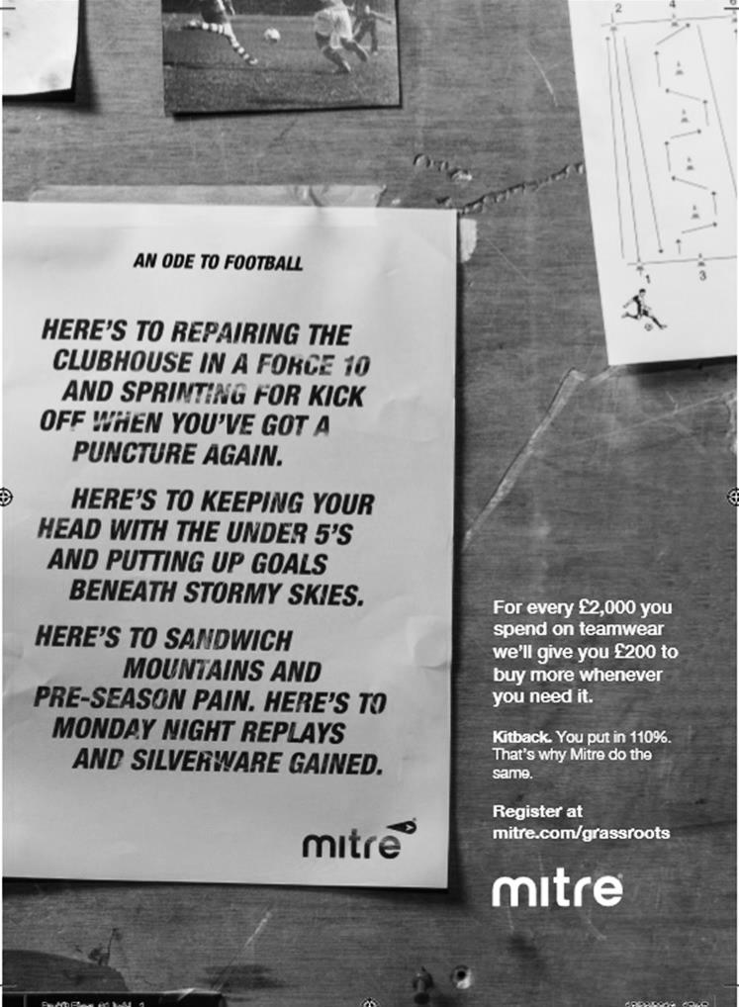

My Club Betting

We can now announce that Epsom & Ewell F.C.
now have our own betting site!

If you like to have a bet, this is most definitely for you.

In conjunction with MyClubBetting.com you can now access all the regular markets that you might do regularly with just a click on our website.

But why would you do this? Many of you already might have apps that you currently use.

The main reason is that you would benefit the club by doing so, but at the same time would not lose out yourselves. Their odds are at least comparable and in many cases better than the other bookmakers out there and by registering with us, the club would make 20% of any cumulative losses and with enough usage, we would qualify for other fairly substantial club benefits.

If you win the bet that you place, that is fantastic news, but whichever company you use currently would keep 100% of any losses. This way our club can receive a nice lump sum in the event that you are unlucky.

For example. If we have 20 people signed up and they lost £25 over the month each, our club would receive £100 back out of the £500 lost.

So just visit: https://eefc.myclubbetting.co.uk/ and join the club, or just visit the link on our main website!

Match and Ball Sponsorships – 2016/17
Opponent | Date | Match Sponsor | Ball Sponsor
Gravesham Borough | 07/08/16 | Club President - Stella Lamont
Gravesham Borough | 07/08/16 | Relocation Committee Member - Mike Lovett
CB Hounslow United | 16/08/16 | EEFC Management Committee
Abbey Rangers | 23/08/16 | Steve & Geoff Dyke
Horley Town (11.30am) | 29/08/16 | In Memory of Chris Henry
Abbey Rangers (LC) | 06/09/16 | Paul Merritt
Camberley Town | 10/09/16 | Building Shop Ltd
Knaphill | 24/09/16 | EEFC Holding Company Director – Pete Lumm
Bridon Ropes (FAV) | 22/10/16 | George and Joseph Saunders
Sutton Common Rovers | 08/11/15 | Alex McKay Senior
Abbey Rangers (FAV) | 13/11/16 | EEFC Holding Company Director – Dave Ellins
Windsor | 15/11/16 | In Memory of Wally Dyke
Bedfont Sports | 19/11/16 | John Bonner
AFC Hayes | 26/11/16 | Jack Jarman
Chipstead (SSC / DWT) | 06/12/16 | Trevor Stotten
Hanworth Villa | 13/12/16 | Roger and Carol Farrell
Chertsey Town | 17/12/16
Raynes Park Vale (11.30am) | 27/12/16 | In memory of Dave and Liz Marshall
Spelthorne Sports | 07/01/17 | Building Shop Ltd
Guildford City (SSC) | 10/01/17 | Super Six Winner – Rita Christian
Guildford City | 17/01/17
Badshot Lea | 04/02/17
Westfield | 18/02/17 | Tony Coome
Walton & Hersham | 04/03/17 | Super Six Winner – Rita Christian
Bedfont & Feltham | 07/03/17 | Programme Editor - Richard Lambert
Hartley Wintney | 18/03/17
Farnham Town | 25/03/17
Colliers Wood United (1pm) | 14/04/17 | Good Friday match – make a note!
North Greenford United | 22/04/17 | Club President - Stella Lamont
For League, League Cup and Surrey Senior Cup Matches:
Match sponsorship - £40.00 Match ball sponsorship - £25.00. Combined £55.00.
For F.A. Cup and F.A. Vase matches:
Match sponsorship - £50.00 Match ball sponsorship - £30.00. Combined £65.00.

Sponsorship includes: (x2 for match, x3 for match and ball)

Admission, programmes, hospitality and advertising and mascot for the day (if required).

If you are interested, just speak to a Committee Member, or drop me an email at: richard.c.lambert@gmail.com


We also thank our Sponsors INTERCEM and G4 Group

Player Sponsorship
Here is the current list for the 2016/17 season showing all of our players and Management that are available for sponsorship.

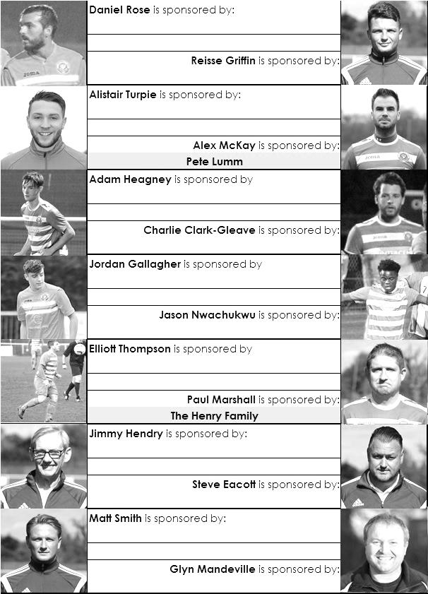

Sponsorship costs just £40 and it is easy to do. Just select a player who has not been previously sponsored and let a Committee Member know that you would like to sponsor them. Beware though. Until we have received the money it is possible for someone to jump in front of you, so don’t delay, sponsor today!
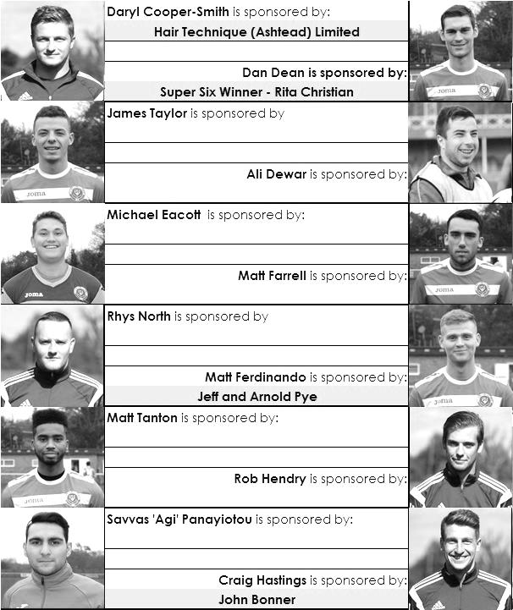

A summary of matches against Walton & Hersham
Epsom Town score one of their goals in the 8-0 win over Walton on 2nd October 1926

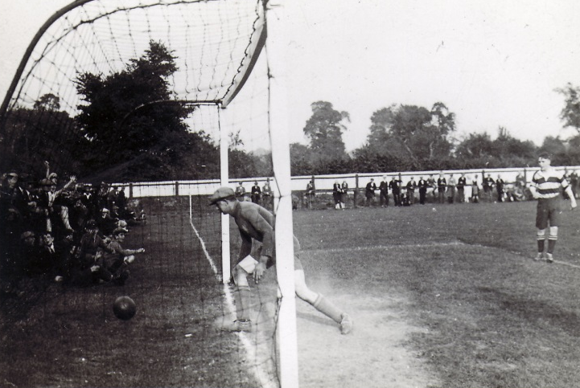
These two teams have recently passed their fiftieth meeting, but our first came on the 22nd November 1924 at Walton’s old ground in Mount Felix, which was situated nearer the town centre of Walton than their current ground. On that day the game was drawn 2-2 but Epsom Town were to have the upper hand in early matches between the teams, including a 5-0 win on 20th February 1926, and then an 8-0 win on 2nd October 1926, both games being played at West Street. The photo (above) shows the Blues scoring one of their eight in the lower goal that day. In six Surrey Senior League matches to 1926/27, we won four and drew two.

We did not meet again until 1937/38 season, when we won twice at West Street, once by 3-1 in the F.A.Cup and the other by two clear goals in a London League match, with the return game at Stompond Lane finishing 2-2.

However, this run was about to end. In 1938/39 the two teams met three times in sixteen days, with Walton winning for the first time 2-1 at home, and although Epsom returned the favour with a 5-3 win at West Street (see programme pictured across page) there was another more important match to come. On 22nd April 1939 the London League Cup Final was held at Stompond Lane, and goals after 40 and 55 minutes sent the trophy to our opponents in a game described as “flat as dishwater” by our local papers, who obviously took the defeat well!

Our only connection with Hersham was a wartime one, with Epsom Town, who used our ground from 1939/45 defeated them 4-2 and 5-0 in 1939/40. Epsom won the Surrey Combination that season with Walton second, and both teams moved to the South Eastern Combination for 1940/41 while Hersham closed down, only to return in 1945 as part of the newly merged Walton & Hersham.

The boot was firmly on the other foot now as Walton, under future Manager Bill Kennedy won the

Corinthian League three times in a row in the late forties. They also defeated our boys 9-1 in the London Senior Cup in 1945 and even their London League team, effectively their Reserves, defeated us 7-3 that year although we won the home League game 5-3 (see programme left).

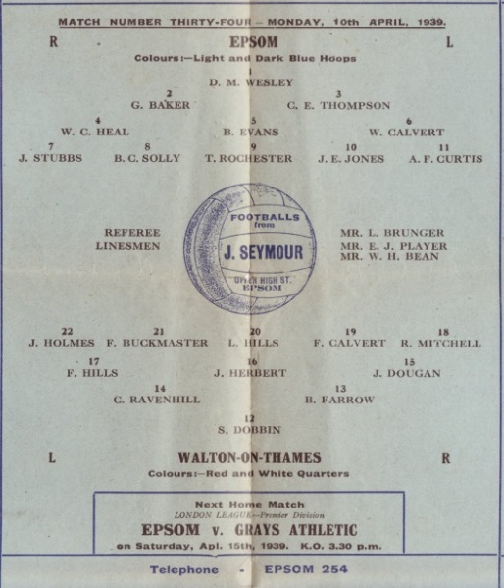
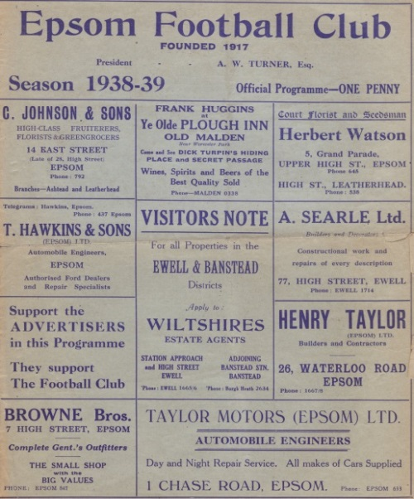
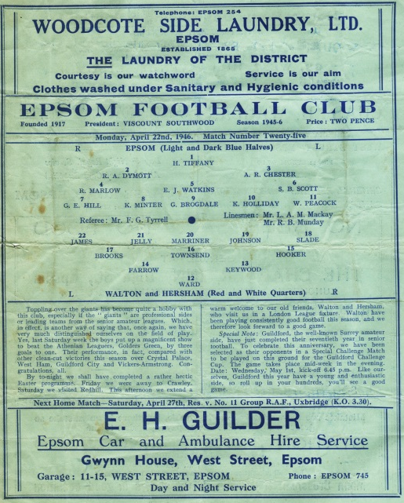
In January of 1949 we were defeated 5-0 in the Surrey Senior Cup, but joined them in the Corinthian League the following season. We technically stopped them from making it four straight titles as we beat them 3-2 at West Street in August 1949, and although they returned the favour in March 1950 (see programme overleaf) by five clear goals, they missed the title by a point from Hounslow.

With their star in the ascendancy for quite a while, we did not meet again until

1977 when they won a replayed F.A.Cup match 2-1 at West Street, but Epsom & Ewell, as we were known by then, were on their way up to the Isthmian Division One where the Swans were now languishing. Over the next six seasons to 1984 and we would meet seventeen times, twelve of these in the League, (winning seven of them) and five in various Cups, including the Southern Combination Cup Final of 1982/83, which was held over, but eventually won by Walton & Hersham on penalties after a 1-1 draw in the August of 1983 (programme - below).

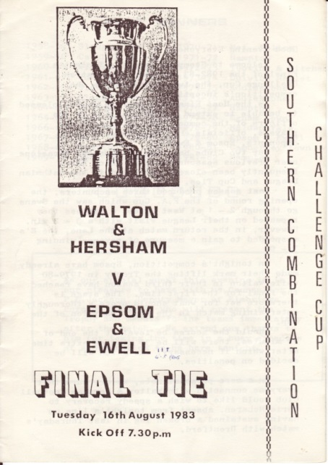
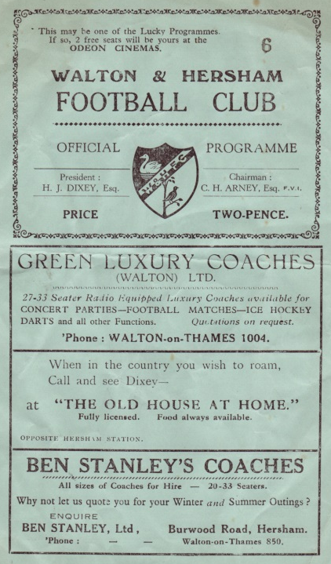
Our promotion to the Premier Division of the Isthmian League kept us apart for two seasons, and results were shared when we returned to Division One for 1986/87, although our second relegation meant that we would meet only sporadically over the next decade, winning three Southern Combination Cup ties and a Surrey Senior Cup match, but losing an F.A.Cup game 5-1 at West Street in 1991.

In 2002 we were briefly back up at Isthmian League Division One South level, and we drew 0-0 at Stompond Lane, winning the home League match 1-0, but in our horrible relegation season of 2003/04, we lost 3-0 at home, and embarrassingly 8-0 away in a match badly affected by the early sending off of our keeper Dave Hyatt, which remains our worst defeat since 1968 when we conceded ten at Lewes.

We then met in a Surrey Senior Cup tie in January 2010 where we trailed early, but aided by two stunning goals from Jamie Hatfield we led 4-1 at the half. However, a second half collapse left us level at 4-4 and we lost 5-4in extra time.

Until this season that had been our last meeting, but we marked the 50th match between the clubs with a 1-1 draw at Stompond Lane in October with Alex McKay putting us ahead. Of course, in our recent meeting in January he put Walton and Hersham ahead with an own goal, but we recovered to win 3-1. Another win here today will give us a top four position again, so here’s hoping!

First Eleven Appearances 2016/17 - (max 44)
Name | Debut | 2016/17 |  |  |  | Career Totals
Name | Debut | App | Sub | Total | Goals | App | Sub | Total | Goals
CLARK-GLEAVE Charlie* | 23/08/2016 | 3 | 2 | 5 | 0 | 3 | 2 | 5 | 0
COOPER-SMITH Daryl | 03/01/2015 | 30 | 5 | 35 | 31 | 60 | 13 | 73 | 51
DEAN Dan | 02/08/2014 | 33 | 2 | 35 | 2 | 101 | 6 | 107 | 4
DEWAR Ali | 29/10/2011 | 0 | 5 | 5 | 0 | 55 | 40 | 95 | 10
EACOTT Michael | 02/08/2014 | 36 | 0 | 36 | 0 | 121 | 1 | 122 | 0
FARRELL Matt | 02/08/2014 | 40 | 0 | 40 | 14 | 126 | 4 | 130 | 32
FERDINANDO Matt | 20/09/2014 | 24 | 8 | 32 | 9 | 77 | 14 | 91 | 23
GALLAGHER Jordan | 07/08/2016 | 30 | 12 | 42 | 11 | 30 | 12 | 42 | 11
GRIFFIN Reisse | 08/08/2015 | 34 | 6 | 40 | 2 | 62 | 12 | 74 | 4
HASTINGS Craig | 08/08/2015 | 27 | 7 | 34 | 2 | 64 | 11 | 75 | 2
HEAGNEY Adam | 16/08/2016 | 29 | 7 | 36 | 0 | 29 | 7 | 36 | 0
HENDRY Rob | 08/08/2015 | 29 | 9 | 38 | 7 | 59 | 20 | 79 | 19
MCKAY Alex | 20/12/2008 | 18 | 4 | 22 | 3 | 126 | 34 | 160 | 11
NEALE Tom* | 13/10/2015 | 6 | 5 | 11 | 7 | 22 | 24 | 46 | 17
NORTH Rhys | 16/08/2015 | 3 | 2 | 5 | 0 | 20 | 9 | 29 | 1
NWACHUKWU Jason | 01/10/2016 | 12 | 10 | 22 | 1 | 12 | 10 | 22 | 1
PANAYIOTOU Savvas | 03/01/2015 | 36 | 4 | 40 | 4 | 68 | 12 | 80 | 11
PRICE Matt* | 23/08/2016 | 2 | 0 | 2 | 1 | 2 | 0 | 2 | 1
ROBINSON Sam* | 22/10/2011 | 7 | 1 | 8 | 1 | 61 | 6 | 67 | 14
ROSE Daniel | 25/10/2016 | 2 | 5 | 7 | 0 | 2 | 5 | 7 | 0
SALEH Mennar* | 24/09/2016 | 0 | 2 | 2 | 0 | 0 | 2 | 2 | 0
SMITH Matt | 08/08/2009 | 0 | 2 | 2 | 1 | 91 | 45 | 136 | 11
TANTON Matt | 02/08/2014 | 35 | 2 | 37 | 1 | 92 | 6 | 98 | 3
TAYLOR James | 26/08/2013 | 36 | 3 | 39 | 2 | 122 | 15 | 137 | 8
THOMPSON Elliott | 09/02/2016 | 3 | 0 | 3 | 1 | 7 | 9 | 16 | 1
TURPIE Alistair | 31/03/2016 | 8 | 1 | 9 | 0 | 10 | 1 | 11 | 0
WATRET Jack* | 02/08/2016 | 1 | 0 | 1 | 0 | 1 | 0 | 1 | 0
* player has left the club

Every Opponent A-Z

Over the years we have played many, many different opponents. Exactly how many is a difficult question, as it all depends on your definition. Are Camberley & Yorktown different to Camberley Town, or are Epsom Town different to Epsom F.C. or Epsom & Ewell F.C.?

In my analysis I have classed both of the above examples as the same team, and will work through them all from A to Z. Some we have played many times, whilst others we have met just once or twice. Enjoy!

VCD Athletic: Played 2 - W1 D1 L0 - F6 A4 - PPG - 2.00 - Very Good

Vickers Crayford Dartford, to give them their full name are a Kent based works team with no connection to Vickers / Vickers Armstrong who were Weybridge based, although both worked in the aircraft parts industry. This club was founded long after the other had folded, starting as recently as 1998. We met them just twice when drawn together in the 2000/01 F.A. Cup First Qualifying Round.

Their ground was being upgraded at the time, so we met at their temporary ground share which was at Thamesmead Town, and a fantastic match ensued. After trailing for much of it we edged ahead 4-3 and looked to have it won, only for a long range wonder strike to secure a 4-4 draw for the home team. Andy Nimmo had scored a hat trick in that match and he would score both goals on the Monday night replay at Merland Rise as we won 2-0 to earn a trip to Horsham in the next round, where the run ended.

VCD returned to their ground at Old Road in Crayford a year or two later and in 2009 were able to earn a place in the Isthmian League but dropped straight out after a season, returning to the Kent League. They bounced back in 2012/13 and won Division One North the following season, even spending the next two terms in the Premier Division at Step Three. Nowadays their neat and tidy ground hosts Step Four football in the North Division once again, despite being based south of the River Thames. I hope they have discounted tickets for the Dartford crossing!

Vickers / Vickers Armstrong: Played 6 - W5 D0 L1 - F36 A9 - PPG - 2.50 - Fantastic

These clubs were the same, but with a name change in 1939/40. We first met at Intermediate level in 1923/24 when we had a lot of hassle from them in the Surrey Intermediate Cup Quarter-Final. We originally drew 2-2 with them in the January at Kings Head Lane, Byfleet after being reduced to ten men through injury. In fact it could have been better as Vickers scored a late equaliser. However we declined to play extra time as it was nearly 5pm so was probably already past sunset and a replay was arranged.

However, later in the week and despite sending their player names to us for the replay and programme, they protested on the basis that extra time hadn’t been played, so the replay had to be delayed, despite our club having already produced programmes and advert posters. So the match was postponed and scheduled for 9th February, moving our big League match with the Dulwich Hamlet Strollers back too, but the protest date was then advised for the 12th February so we had two wasted Saturdays before the Surrey F.A. decided we would go back to their place for the replay, where we promptly destroyed them 6-1, although lost in the Semi-Final to Redhill.

In 1926/27 we met them again after they had been elected to the Surrey Senior League, but this was our stellar year, winning the League and Cup and we again dominated proceedings. That is, once we had finally played them. We were due to host them on 9th April but they then contacted the club at 11.30 in the morning to say that they couldn’t raise a side, leading to a postponement,

again, too late to let everyone know in those pre-internet days.

Vickers then fielded a Reserve team in a fixture against Egham that afternoon, so we claimed costs from them. It’s fair to say that the two clubs probably didn’t get on! Vickers were then “ordered” by the Surrey Senior League to turn up for the next fixture at Epsom and were promptly thrashed 7-2 at West Street on 23rd April and then 8-0 in Byfleet on Wednesday 2nd May.

We met twice more under the amended name, although it should be pointed out that we had also changed names by then from Epsom Town to Epsom F.C. and we defeated them 5-0 at home in a London League match, although slipped up in the return by five goals to four in February 1946.

They then spent a few years in the Metropolitan League in the early fifties, but we met them twice more in consecutive seasons in Amateur Cup ties. By now they were again known simply as Vickers and had rejoined the Surrey Senior League in 1957. We won 7-0 in Byfleet in September 1957 and 5-2 at West Street in September 1958.

They remained in the Surrey Senior League until 1964 when they resigned and I have no further trace of them after this point, as is often the case with works clubs.

Virginia Water: Played 6 - W4 D1 L1 - F12 A5 - PPG - 2.17 - Very Good

Virginia Water are a club we have only played briefly, like the others in this week’s segment. However, they do hold a prominent place for a couple of reasons.

We first met on our demotion to the Surrey Senior League in 1973, although our two League matches were not played until April and May of 1974. We won 2-0 at West Street, thanks to a pair of second half goals from Dave Ritman but were held 1-1 in the return on our first visit to The Timbers in Crown Road on Tuesday 7th May.

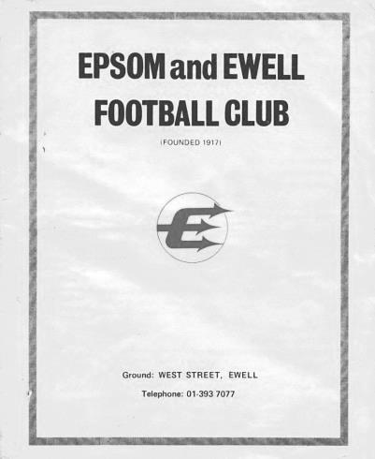
In 1974/75 we would meet them three times. The first meeting in our tremendous Vase Final season was straight forward enough as we won 3-1 over there but the goal conceded was the only one we would let in during our opening seven matches of the season, during which time we had scored 26 of our own!

Worse was to come as they defeated us 2-0 at West Street on Saturday 30th November 1974 (see programme) to hand us our only League defeat of the season. The only other points we would drop all season were in a pair of late season draws with Malden Town. We got revenge on Wednesday 23rd April at Fetcham Grove, Leatherhead F.C. in the League Cup Final when 600 spectators watched us win 3-1. We didn’t concede many that year, yet they scored in all three matches against us!

Our final meeting came in a Southern Combination Cup tie where we were drawn away, but as they didn’t have floodlights for this midweek competition, we met at Krooner Park, home of Camberley Town, and this time we did register a clean sheet with a 3-0 win on Tuesday 2nd November 1976, thanks to a pair from Tommy Tuite and one from Gary Lee.

Times have been lean for Virginia Water who have been in and out of the Surrey Senior League since then, with a regular spell ending in 1987 and one final season in 1993/94. They are rumoured to be making a return to the Combined Counties League next season as they are fourth in the Surrey Elite but with many games in hand. Maybe after all this time we will be at The Timbers in a League Cup tie next year!

From behind the goal
Spelthorne Sports 2-2 Epsom & Ewell
Combined Counties League - Premier Division - Saturday 25th February 2017

Entertaining but frustrating contest ends all square at the Sports Club

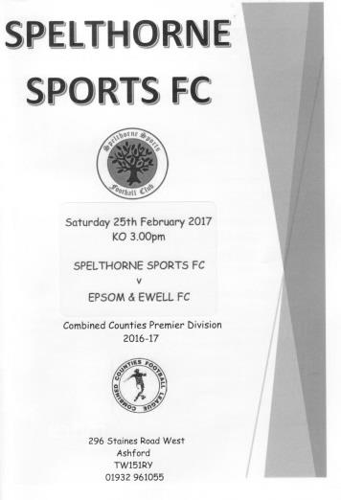
An 87th minute equaliser from Dan Dean ensured that we avoided defeat at Spelthorne Sports, although it probably feels to most Epsom players and supporters that we had dropped two points in this match. Ironically, the home side may well be happier with the result, having taken their first ever League point against us in six attempts, not to mention ending our six match winning run in a contest where both teams played their part, but on the balance of play we were left to regret missed opportunities that could have made this a more comfortable afternoon's work.

Although Manager Glyn Mandeville was absent, Assistant Manager Matt Smith took the reins and he named an unchanged starting eleven from the team that had played so well at Abbey Rangers on Monday. We made a good start, earning a penalty inside four minutes. Unfortunately, this is the point when I have to start referring to the official in charge. He had played well for the first three minutes, but when the home keeper William Price dropped an Agi Panayiotou free kick, the ball fell to James Taylor who was then tackled, rugby style with both hands around his waist, clearly preventing him from getting a shot at goal from ten yards out. A quite obvious penalty. However, the laws have been changed this year to make it clear that the offence that earns the red card is when someone has prevented a goal scoring opportunity and that pushing, pulling or handballs would still attract the same punishment. It was never about whether there were other men around and Price should have received a red card for this. Typically, he then saved Matt Farrell's penalty, although he was well off his line by the time Farrell struck it.

Ten minutes later we should have had another penalty when Daryl Cooper-Smith had a defender all over him, pulling away at his shirt but this was either missed or ignored. We then trailed in the 16th minute when the home side made their first venture out of their half and floated a good ball over the back of Adam Heagney to their front man Lee Staples. He had pulled away well but his control let him down a bit and the ball looked like it would get away from him. However, he then won the 50/50 tackle with Taylor and then curled the ball beyond Michael Eacott into the far bottom corner. This was harsh on our boys but we responded well and Cooper-Smith drilled Reisse Griffin's lay off just wide of Price's right hand post from the edge of the area. however, we nearly conceded again when Heagney tried to see the ball out but a striker kept the ball in play and sent his pass to the far post, where the shot came in, although Eacott made a comfortable save.

Football is a strange game. We were just beginning to look as though we had lost our way a bit when we equalised. What appeared to be a poor ball forward from Dean was miscontrolled by the defender and Jason Nwachukwu pinched the ball off him, running at goal and putting Cooper-Smith through, from where he drew the keeper before lifting it over him for the equaliser in the 35th minute. As the half ended Dean met a Jordan Gallagher corner with a looping header which just dropped over the bar. As the players trooped off it was concerning that we had only played 45 seconds over time as the referee's lectures had taken nearly three minutes out of the half. If there genuinely is a need to have a word with players then fair enough, but the watch must surely be stopped in these circumstances.

With the majority of the wind on a gusty day being behind us, we started the second half well. Cooper-Smith was put through by a Nwachukwu header but he was a little wide and his attempted flick across goal with the outside of his foot was cut out by Price. He was the recipient of a fine long ball from Heagney shortly after this but again was in a similar position to the previous situation and this time went for the near post, missing it by less than a foot and sending the ball into the side netting.

Still we had to be on our guard and a good ball over our defence put their striker through, but Eacott stood up well and deflected the shot wide for a corner that we cleared. The game became a little stretched for a while and took a nasty turn when Gallagher was taken out on the left touchline long after he had delivered his cross. The referee completely missed the incident in question. As a result it was intensely frustrating to see the same thing happen just two minutes later with Gallagher receiving a stud injury to his knee. He then went to show the referee the stud mark and was booked for his trouble. A more idiotic decision I have not come across in recent years, and it transpired after the match that the booking was for simulation!! Apart from this ludicrous assertion, if you were going to book someone, you would go over straight away once the ball was out of play and do so. You don't wait two minutes while our player is lying there, then eventually gets up and wanders over to the referee before doing so. He clearly did not see the incident which was bad enough, but to then try to cover himself in this way was embarrassing!

Despite this, Gallagher limped on for a while and a few minutes later was able to join in an attack when Griffin set him up for a low shot which was well saved by the diving Price and then headed away for a corner by a nearby defender. Ferdinando came on for Nwachukwu but we were behind again in the 74th minute. Griffin lost the ball out on the touchline and tried to bring his man down, but for the first time in the match the advantage rule was played and Spelthorne spread their attack from left to right. A cross was flicked on and met with a stylish volley of a dropping ball from Tommy Mooney that gave Eacott no chance from just inside the area.

This was serious. With just 15 minutes remaining we would need something special. We nearly went three - one behind with a shot that was dragged just beyond our far post but then started to attack solidly for the remainder of the game. Rob Hendry replaced Griffin but within a minute we had picked up two more bookings, the first for Ferdinando who reacted badly to a challenge that was considered a foul and then moments later Farrell picked up a yellow card too after approaching the referee. You might have thought this was for dissent, but it transpired that it was for persistent foul play, despite our man not being directly involved in the attack that had ended with Ferdinando's foul, and the fact that play hadn't even restarted. The well known referee Mark Halsey wrote recently that a good referee doesn't go looking for trouble. This fella brought his map and compass!

We then saw a home player pick up a harsh booking for a foul on Farrell which definitely appeared to fall in the "evening it up" category, but simply wasted more of our time as we pressed for the win. We then had a few minutes of injury time after a poor defensive header put a Spelthorne player through but as he took the ball around the exposed Eacott, Dean made the firm but fair challenge, leaving him requiring treatment.

As time was running out a clipped cross in from Hendry was headed back by Ferdinando to Farrell but his volley was just wide of the keeper's left hand post. However, we then earned a corner in the 87th minute and after retrieving the ball that had been kicked away by the defender, obviously with no punishment given, Panayiotou's delivery enabled Dean to get there just ahead of the keeper and he nodded the ball in from around six yards.

As we went into injury time we had two great chances to seal the match, and I really thought we had won it when Ferdinando cut the ball back for Cooper-Smith in time and space just ten yards out, but his shot was brilliantly deflected over the bar by Price, who probably didn't know which part of him the ball was going to hit but deserved credit for getting out quickly. We then had another attack with some good play around the edge of the box and the opportunity fell to Gallagher on the right hand side but his shot went just beyond the far post.

On another day we would have won this match at a canter but difficult as it may be, we have to keep our heads a little better and not become distracted by the things they can't control. There were poor decisions for both teams, always a sign that the officiating was poor, but we need to be rising above it. With exception of the red card situation for the early penalty, none of the decisions were key to costing either team the match, but it was like a circus out there at times with one person clearly wanting to be the ringmaster, although another performer often seen at a circus was a more appropriate description.

I really wanted the story of this match to be about how two fully committed teams gave everything out there and produced a fantastic match for the neutral and was well refereed. Two out of three isn't bad though and as we move on to the home match against Walton & Hersham on Saturday we just need to be thankful that no players received serious injury out there. Seven days after a wonderful refereeing performance I have to report that the best official on the field in this match was the replacement Assistant, who I believe was the Spelthorne Chairman, filling in for an absent Assistant.

Epsom and Ewell: Michael Eacott, Adam Heagney, Matt Tanton, James Taylor, Dan Dean ©,
Savvas 'Agi' Panayiotou, Jordan Gallagher, Matt Farrell, Daryl Cooper-Smith, Jason Nwachukwu, Reisse Griffin

Subs: Matt Ferdinando for Nwachukwu (71), Rob Hendry for Griffin (76)

Combined Counties League Premier Division
Opponents All-time Records
incl Saturday 25th  February | P | W | D | L | F | A | PPG | GD | Best  Win | Worst  Loss
Bedfont & Feltham | 1 | 1 | 0 | 0 | 9 | 2 | 3.00 | +7 | 9-2 | X
Spelthorne Sports* | 7 | 5 | 2 | 0 | 15 | 6 | 2.43 | +10 | 6-2 | X
Sutton Common Rovers | 12 | 9 | 2 | 1 | 30 | 14 | 2.42 | +16 | 4-0 | 1-4
Abbey Rangers | 4 | 3 | 0 | 1 | 11 | 4 | 2.25 | +7 | 7-1 | 2-3
Horley Town | 29 | 20 | 5 | 4 | 65 | 30 | 2.24 | +35 | 6-0 | 1-3
Colliers Wood United | 22 | 14 | 2 | 6 | 45 | 33 | 2.00 | +12 | 4-0 | 0-5
Bedfont Sports | 10 | 6 | 2 | 2 | 18 | 11 | 2.00 | +7 | 5-1 | 0-4
Westfield | 20 | 12 | 3 | 5 | 42 | 32 | 1.95 | +10 | 6-1 | 0-4
Guildford City | 18 | 11 | 1 | 6 | 35 | 22 | 1.89 | +13 | 5-1 | 1-5
Farnham Town | 14 | 8 | 2 | 4 | 25 | 23 | 1.86 | +2 | 3-1 | 1-4
Knaphill | 7 | 4 | 1 | 2 | 15 | 8 | 1.86 | +7 | 4-0 | 1-2
Badshot Lea | 19 | 9 | 3 | 7 | 39 | 36 | 1.74 | +3 | 4-1 | 0-4
Walton & Hersham | 51 | 25 | 10 | 16 | 104 | 98 | 1.67 | +6 | 8-0 | 1-9
Hanworth Villa | 17 | 8 | 4 | 5 | 38 | 27 | 1.65 | +11 | 5-0 | 1-4
Raynes Park Vale | 28 | 13 | 7 | 8 | 59 | 38 | 1.64 | +21 | 6-1 | 0-2
Camberley Town* | 89 | 38 | 22 | 28 | 158 | 123 | 1.52 | +35 | 9-1 | 0-4
Hartley Wintney | 11 | 4 | 3 | 4 | 26 | 20 | 1.36 | +6 | 5-0 | 2-4
Windsor | 49 | 19 | 12 | 18 | 90 | 90 | 1.41 | 0 | 4-0 | 0-6
Chertsey Town | 49 | 19 | 5 | 25 | 75 | 87 | 1.27 | -12 | 3-0 | 0-7
North Greenford United | 11 | 3 | 2 | 6 | 15 | 20 | 1.00 | -5 | 3-0 | 1-4
CB Hounslow United | 3 | 1 | 0 | 2 | 4 | 7 | 1.00 | -3 | 2-0 | 1-5
AFC Hayes | 10 | 2 | 3 | 5 | 18 | 18 | 0.90 | +1 | 7-0 | 0-3
* includes one abandoned match v Camberley and one loss on penalties v Spelthorne

Salts Super Six Predictor
The Salts Super Six Predictor is live again for today’s match and the tickets are on sale at today’s game to the left of the gate. The matches are to be played today.

The jackpot was claimed last week and restarts this time at £100 so it won’t be long before it is climbing again!

The competition is easy to play! To win, you simply need to predict the results of six matches correctly from the three options, fill in the form and make sure it is back with our seller before the deadline on the ticket. The latest fixtures are shown below.

If you are a club regular, you just need to place your name on the sheet, although if you aren’t, then we’ll need a contact number from you too. We will announce any winners on the website within three working days, so don’t worry, we won’t miss you!

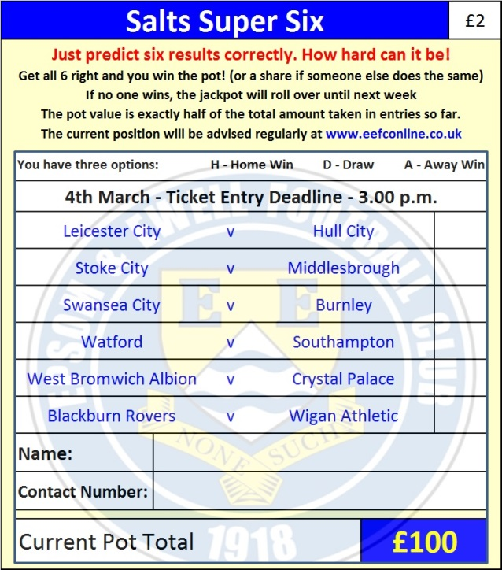
Please note that if there is more than one winner, the prize pot would be shared between the winners. All you need to do now is have a go, as many times as you like!

Good luck!

Combined Counties League – Premier Division
Saturday, 4th March 2017 - Kick-off 3.00 p.m.

Epsom and Ewell  (Royal Blue & White hoops) | V |  | Walton & Hersham  (All Red)
Squad | NUMBERS |  | Squad
Michael Eacott |  |  | Liam Beach
Adam Heagney |  |  | Corey Haywood-Roye
Matt Tanton |  |  | Howard Newton
James Taylor |  |  | Louis Taylor
© Dan Dean |  |  | Lea Van Sullivan
Savvas ‘Agi’ Panayiotou |  |  | Jamie Thoroughgood
Jordan Gallagher |  |  | Malachi Thomas
Matt Farrell |  |  | Billy Marshall
Rob Hendry |  |  | Francois Gabbidon
Matt Ferdinando |  |  | Jamil Okai
Reisse Griffin |  |  | T.J. Nkoma
Jason Nwachukwu |  |  | Seb Castello
Craig Hastings |  |  | Alex Filipe
Daryl Cooper-Smith |  |  | Sean White
Alex McKay |  |  | Cameron Gyeabour
Ali Dewar |  |  | Craig Tanner
Alistair Turpie
Matt Smith
Daniel Rose
Glyn Mandeville | MANAGER |  | Simon Haughney
Matt Smith | ASSISTANT
Steve Eacott / Alex McKay/  Jimmy Hendry | COACHES / PHYSIO |  | Howard Newton / Paul Thomas / Tiffany Weedon
REFEREE: D.Laing
ASSISTANTS: M.Flannery-Pratt, R.van Neikerk
Today’s match and Match Ball are kindly sponsored by
Rita Christian, our latest Salts Super Six winner

OUR NEXT VISITORS TO HIGH ROAD
Bedfont & Feltham
Combined Counties League – Premier Division
Tuesday 7th March 2017 – 7.45 p.m.

